COMPUTER PROGRAMMING (CP-I)
LAB REPORT



Submitted By :
TAKREEM NAVEED
2022-MC-14
Submitted To:
Ma’am Quratulain Masood
KNIGHTS TOUR PROBLEM

DEPARTMENT OF MECHATRONICS AND CONTROL ENGINEERING
UET, LAHORE
Title Page
KNIGHT TOUR USING GENETIC ALGORITHM
Table of Contents
- Introduction
- Methodology
- Flow chart
- Implementation of Genetic Algorithm
- Results
- Discussion
- References.

Introduction:
The Knight's Tour Problem involves finding a sequence of moves for a knight on a chessboard, such that the knight visits every square exactly once.
This project uses a genetic algorithm to evolve a population of solutions to find an optimal or near-optimal solution to the Knight's Tour Problem.
Objective:
Implement a genetic algorithm to evolve a population of potential solutions (chromosomes) for the Knight's Tour Problem.
Optimize the arrangement of knights on the chessboard to cover all squares without attacking each other.
Algorithm Components:
Chromosome Representation:
The solution is represented as a Chromosome struct consisting of a 2D array (knights) representing the placement of knights on an 8x8 chessboard and a fitness value indicating the quality of the solution.
Genetic Operations:

- Initialization: The initial population (POPULATION_SIZE) is randomly generated.
- Fitness Calculation: The fitness of each solution is evaluated by counting the number of unattacked squares by knights.
- Selection and Crossover: Parents are selected based on fitness, and a two-point crossover operator swaps genetic material to produce offspring.
- Mutation: A mutation rate of 5% is applied, toggling the presence of knights randomly.
- Algorithm Execution:
  - The algorithm runs for a fixed number of generations (MAX_GENERATIONS), performing fitness evaluation, selection, crossover, mutation, and replacement of the old population with the new offspring.
- Sorting:
  - Bubble sort is used to sort the population based on fitness.

Implementation Details:
- Population Initialization: Generates a population of random solutions.
- Fitness Function: Evaluates fitness by counting unattacked squares.
- Crossover: Exchanges genetic material between parents using a two-point crossover.
- Mutation: Randomly toggles the presence of knights based on a mutation rate.
- Sorting: Bubble sort is implemented for sorting the population based on fitness.

Results:
Display the best fitness and corresponding chessboard arrangement for each generation.
Track the evolution of the population towards a solution.
Conclusion:
Genetic algorithms provide an effective approach to solving combinatorial optimization problems.
The project demonstrates the application of genetic algorithms to the Knight's Tour Problem.
Future Work:
Experiment with different population sizes, crossover rates, and mutation rates for further optimization.
Extend the algorithm to handle larger chessboards or variations of the Knight's Tour Problem.

FLOW CHART 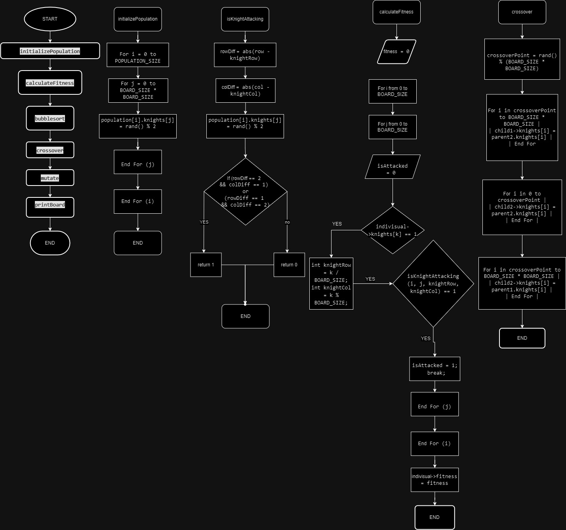

PSEUDO CODE :
Following is the pseudo code for this problem

Procedure Main():
Initialize random number generator-

// Initialize the population with random chromosomes
RandomBoards(population)

for generation = 0 to maxGenerations - 1
// Calculate fitness for each chromosome in the population
for i = 0 to PopulationSize - 1
fitnessfunction(&population[i])

// Sort the population based on fitness
NextGeneration(population)

// Crossover and mutation to create the next generation
for i = 0 to PopulationSize - 1 step 2
crossover(&population[i], &population[i + 1], &offspring[i], &offspring[i + 1])
mutation(&offspring[i])
mutation(&offspring[i + 1])

// Replace the old population with the new one
for i = 0 to PopulationSize - 1
population[i] = offspring[i]

// Find the best solution in the final population
Solution = &population[0]
for i = 1 to PopulationSize - 1
if population[i].fitness < Solution.fitness
Solution = &population[i]

// Display the best solution
print "Best solution found in generation", generation, ":"
printBoard(Solution)
Implementation:
Written in C programming language.
Utilizes functions for initialization, fitness calculation, crossover, mutation, and sorting.
Incorporates a loop for the evolution of the population over a specified number of generations.
Results:
- The algorithm iterates through generations, attempting to find a solution that minimizes the number of unattacked squares on the chessboard.

- The best solution found is displayed, showing the placement of knights on the board.

Conclusion:
The genetic algorithm approach attempts to find a solution to the Knight's Tour Problem by evolving and improving candidate solutions over multiple generations. The final solution represents a configuration of knights on the chessboard that aims to cover as many squares as possible.
Future Work:
Experiment with different population sizes, crossover rates, and mutation rates for further optimization.
Extend the algorithm to handle larger chessboards or variations of the Knight's Tour Problem.

- REFERENCES
I have used following references for my project of knight’s problem solution
- Google, bing.chatgpt,youtube
- https://app.diagrams.net/
- sample solution of n queen problem
- The algorithm terminates either when a valid solution is found or when it reaches a predefined maximum number of iterations without finding a valid solution.

